# Objective

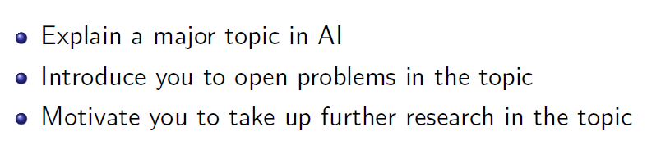

Not including COMS30035 EMATM0053

# Terms

Agent

An agent is autonomous

capable of deciding for itself and performing independent actions

Agents

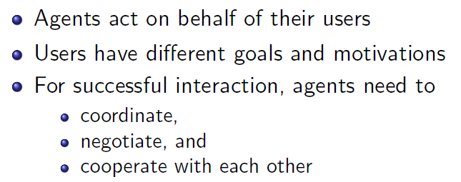

Environment

Accessible vs Inaccessible

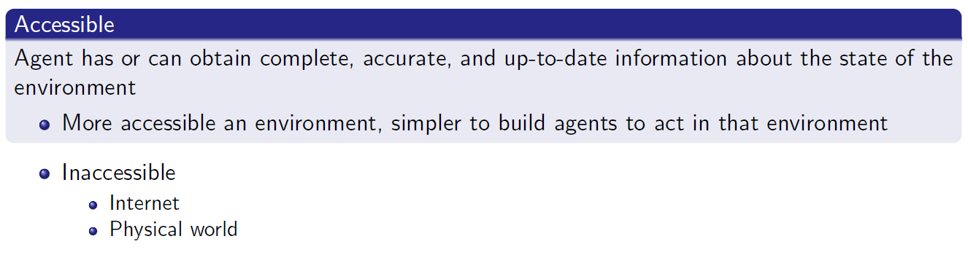

Deterministic vs Non-Deterministic

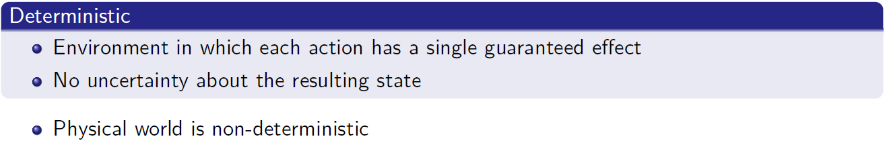

Episodic vs Non-Episodic

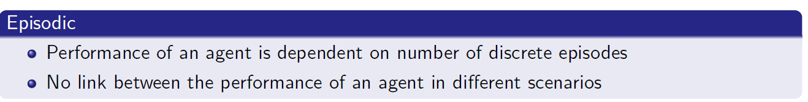

Static vs Dynamic

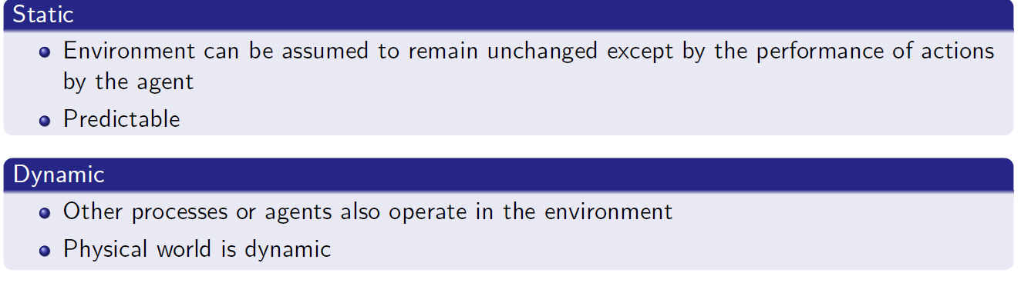

n(sbj, obj, ant, con)

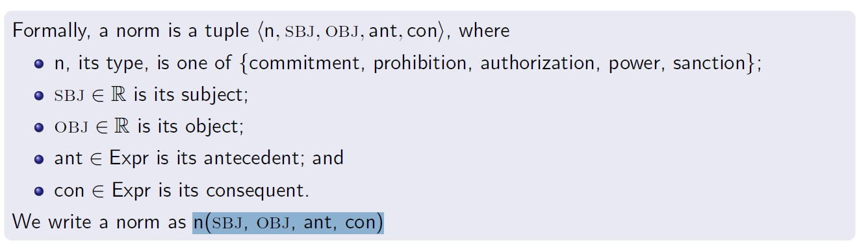

Types of Social Norms

commitment, prohibition, authorization, power, sanction

承诺、禁止、授权、权力、制裁

Speech Acts

Informative Directive Commissive

Sequence Diagrams

State Transition Diagrams

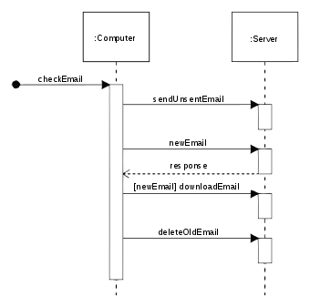

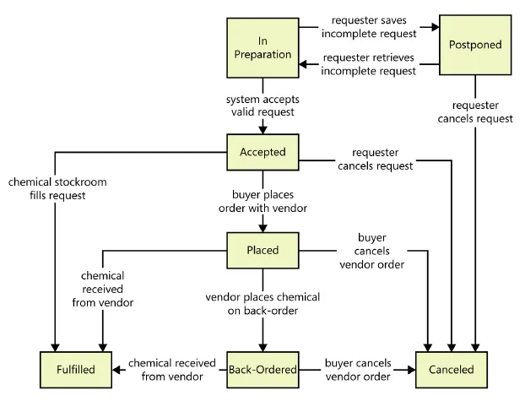

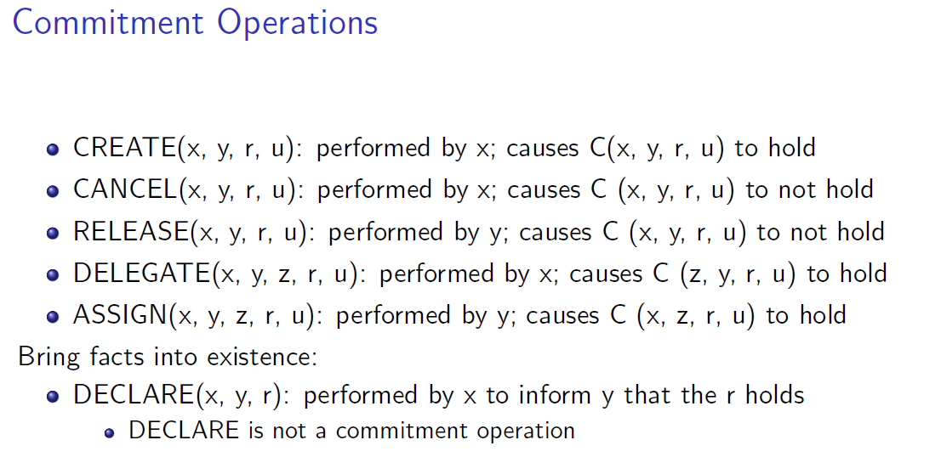

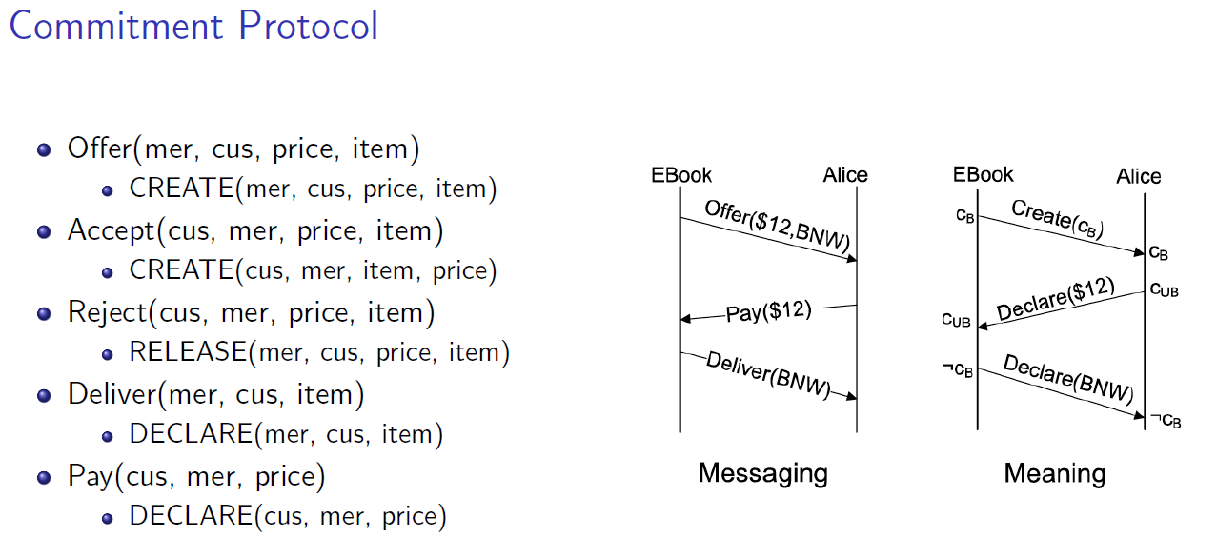

# Lab

Mesa Library – Python

# Simulation Framework

SUMO

https://www.eclipse.org/sumo/